**SIR APOLLO**

**END OF TERM III EXAMINATION 2023**

**P.6 INTEGRATED SCIENCE**

***Time Allowed: 2hours 15 Minutes***

**Pupil’s Name: …………………….…………………………………….……**

**Class: ………………………………………..……………………………………**

**School Name: …………………………………………………………….**

|  |  |  |
| --- | --- | --- |
| **FOR EXAMINERS’**  USE ONLY | | |
| **Qn. No.** | **MARKS** | **EXR’S**  **No.** |
| **1 - 10** |  |  |
| **11 – 20** |  |  |
| **21 – 30** |  |  |
| **31 – 40** |  |  |
| **41 – 43** |  |  |
| **44 – 46** |  |  |
| **47 – 49** |  |  |
| **50 - 52** |  |  |
| **53 - 55** |  |  |
| **TOTAL** |  |  |

**Read the following instructions carefully:**

1. This paper has two sections: **A** and **B**
2. Section **A** has 40 questions (40 marks)
3. Section **B** has 15 questions (50 marks)
4. Answer all questions. All the working for both sections A and B must be shown in the spaces provided.
5. All working must be done using a blue or black ball point pen or ink. Any work done in pencil will NOT be marked except drawings and diagram.
6. Unnecessary changes in your work and handwriting that cannot be easily read may lead to loss of marks.
7. Do not fill anything in the table indicated

**“For examiners’ use only”** and the boxes inside the question paper.

***Turn Over***

**SECTION A: 40 MARKS**

1. Which component of soil is formed through decomposition of plants and animals?

______________________________________________________________________________

1. Identify one method of controlling pests.

______________________________________________________________________________

1. In which part of the alimentary canal of a bird is food stored and moistened?

______________________________________________________________________________

1. Write down one part on your body where germs can enter from.

_____________________________________________________________________________

1. Give any one example of a root tuber.

_____________________________________________________________________________

1. Suggest one way in which water is used as energy resource.

_____________________________________________________________________________

1. Give one reason why people keep dogs in their homes.

_____________________________________________________________________________

1. Name one important mineral salt included in chicken feeds to harden the egg shells and strengthen their bones.

____________________________________________________________________________

1. A part from ferns, give one other non-flowering plant which reproduces by means of spores.

_____________________________________________________________________________

1. Which element of PHC helps to reduce deficiency diseases in children?

_____________________________________________________________________________

1. Apart from suckers, what else can be used to propagate pineapples?

_____________________________________________________________________________

1. Name one mammal that moves by flying.

_____________________________________________________________________________

1. How are canine teeth adopted to tearing flesh?

_____________________________________________________________________________

1. How long is the gestation period of a cow?

_____________________________________________________________________________

1. Name any one natural source of sound.

_____________________________________________________________________________

1. Give one reason why a P.7 pupil should delay to have sex.

_____________________________________________________________________________

1. State the type of change that takes place when a baby grows in to an adult.

_____________________________________________________________________________

1. Mr. Musisi lives with his wife, son, and nephew. What type of family is this?
2. _____________________________________________________________________________
3. Give one example of a leguminous plant.

_____________________________________________________________________________

20. Wako shouted in the main hall and he heard the same sound repeated. Suggest one way the

repeated sound he heard can be reduced in the main hall.

_____________________________________________________________________________

21. How is the fertilization of the eggs of a frog different from those of a crocodile?

________________________________________________________________________________

________________________________________________________________________________

22. What is the importance of water during seed germination?

________________________________________________________________________________

23. Give one way a P.6 pupil can promote immunization in the family.

________________________________________________________________________________

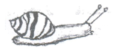 **The diagram below is of a common animal. Use it to answer questions 24 – 26.**

24. Why is the animal above grouped under invertebrates?

________________________________________________________________________________

25. Use letter P on the diagram above to show the part used by the above animal for protection.

________________________________________________________________________________

26. Which disease does the above animal spread to humans?

_________________________________________________________________________________

27. Name the water habitant disease which affects red blood cells.

________________________________________________________________________________

28. State any one property of matter.

________________________________________________________________________________

29. Name the body organ which helps a person to know whether the temperature is high or low at night.

________________________________________________________________________________

30. Name the cattle disease whose sign is a swollen painful udder.

________________________________________________________________________________

31. Which structures enable the trachea to remain open all the time?

________________________________________________________________________________

32. Name the part of the human ear that helps to balance the body.

________________________________________________________________________________

33. State one use of soil to earth worms.

________________________________________________________________________________

34. State one method used to make dirty water clean.

________________________________________________________________________________

35. In the space below draw a simple diagram of tap root system.

36. State one example of an animal fibre.

________________________________________________________________________________

37. How are scavenger birds useful in the environment?

________________________________________________________________________________

38. Mention one reason why people drain wetlands.

________________________________________________________________________________

39. Why are bees considered to be social insects?

________________________________________________________________________________

40. Which part of a seed grows into the shoot system after germination?

**SECTION B**

41. **Below is a diagram showing a habitat of an arachnid.**

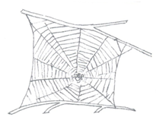

a) Name the structure drawn above.

________________________________________________________________________________

b) Which animal lives in the structure above?

________________________________________________________________________________

c) A part from being its habitat, how is the above structure useful to the animal named in (b) above?

________________________________________________________________________________

d) How can the animal whose home is shown above be useful in the control of malaria?

________________________________________________________________________________

42. a) Name two types of pollination in flowering plants.

i) ________________________________________ ii) __________________________________

b) Write down any two agents of pollination.

i) ________________________________________ ii) ___________________________________

43.a) Give any two disadvantages of keeping local breeds of cattle.

i) ______________________________________________________________________________

ii) _____________________________________________________________________________

b) A part from getting meat and milk, give any two other ways a farmer benefits from keeping cattle.

i) ______________________________________________________________________________

ii) ______________________________________________________________________________

44. **The diagram shows a musical instrument. Use it to answer questions about**

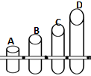

a) What type of musical instrument is shown in the diagram above?

________________________________________________________________________________

b) How does the above instrument produces sound?

________________________________________________________________________________

c) Which pipe produces the highest pitch of sound?

________________________________________________________________________________

d) Which term defines the highness or lowness of sound?

_______________________________________________________________________________

45. Write down the way each of the following animals protects itself against enemies.

a) Chameleon - _____________________________________________________________________

b) Millipede- _______________________________________________________________________

c) Cobra - _________________________________________________________________________

d) Bedbug - ________________________________________________________________________

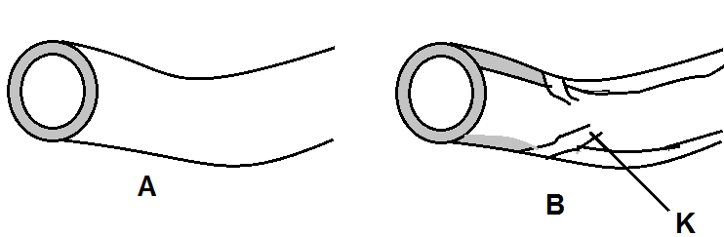46. **The diagram shows the types of blood vessels in a human body.**

a) Name the body system the organs shown in the diagrams above belong.

_______________________________________________________________________________ __

b) Name the blood vessels labeled A and B.

i) A ____________________________________ ii) B _____________________________________

c) Of what importance are structures marked K in blood B?

_________________________________________________________________________________

47. Write down four requirements a farmer should consider before starting a farm.

i) ______________________________________ ii) ____________________________________

iii) _____________________________________ iv) _____________________________________

48.a) Name any two water borne diseases.

i) _____________________________________ ii) ______________________________________

b) In which two ways can water-borne diseases be prevented in the community?

i) _______________________________________________________________________________

ii) _________________________________________________________________________

49. **The diagram below is of a fish.**

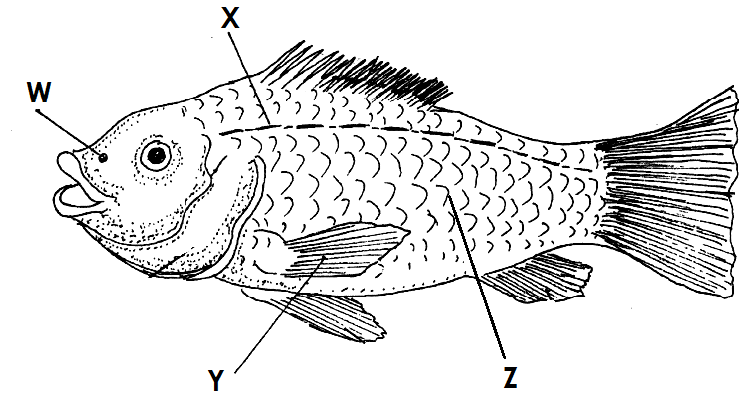 a) Name parts marked with letters:

i) X _____________________________

ii) Y _______________________________

b) Give the function of part labeled:

i) W _____________________________________________________________________________

ii) Z ______________________________________________________________________________

50. a) A part from worker bees, mention two other types of bees found in the hive.

i) _____________________________________ ii) ____________________________________

b) Write down two materials collected by worker bees from the environment.

i) ____________________________________ ii) _____________________________________

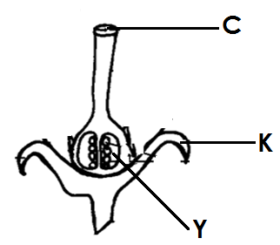51. **The diagram shows part of a flower. Use it to answer questions which follow.**

a) Which part of flower is shown in the diagram?

________________________________________________________________________________

b) What happens to pollen grains when they land on part marked C?

_______________________________________________________________________________

c) Which important process occurs in part K?

_______________________________________________________________________________

d) State one use of part Y.

_______________________________________________________________________________

52.a) Give one reason why it is important to perform the following activities:

i) Washing hands before eating food.

____________________________________________________________________________

ii) Brushing teeth after meals.

___________________________________________________________________________

b) A part from washing hands and brushing teeth, state other activities one can do to maintain

personal hygiene.

1. _______________________________________________________________________

Ii ________________________________________________________________________

53.a) What do you understand by the term First Aid?

_______________________________________________________________________________

b) Give two reasons why we should give first aid.

i) ______________________________________________________________________________

ii) ______________________________________________________________________________

c) Draw and name one equipment found in the first Aid Box.

________________________________

54. **The diagram shows the reproductive system of a cow. Use it to answer questions.**

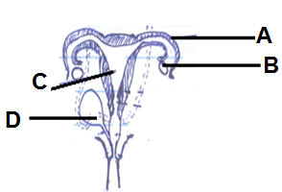

a) Name part marked B and D.

i) B _________________________________ ii) D _____________________________________

b) Which letter shows where the following activities takes place?

i) Fertilization - _________________________________________________________________

ii) Development of the foetus ___________________________________________________

55.a) Name the garden tool used to carry manure and harvested crops on the form.

_______________________________________________________________________________

b) Give the importance of painting metallic garden tools.

_________________________________________________________________________________

c) A part from painting, state one other way of caring for garden tools.

_______________________________________________________________________________

d) Suggest one factor considered when selecting a site for a school garden.

_______________________________________________________________________________

**END**